

CP5046: ICT Project 1

ROMASHKA

# Project Audit

# Lecturer: Laura Antochi

**Team Members:**

Anastasia Verchak ID: 13446694

Charanpreet Kaur ID: 13543377

Harshitha Paderu ID: 13539782

**TABLE OF CONTENTS**

|  |  |
| --- | --- |
| **TITLE** | **PAGE NO.** |
| ***ABSTRACT*** | ***3*** |
| ALPHA RELEASE | 4 |
| Home Page | 5 |
| Login Page | 7 |
| Registration Page | 10 |
| INDIVIDUAL CONTRIBUTION | 12 |
| ALPHA RELEASE PROBLEMS AND CONCLUSION | 13 |
| TRACKING PROGRESS FOR ALPHA RELEASE |  |
| Burndown Chart | 14 |
| Velocity Chart | 15 |
| Analysis | 16 |
| TECHNICAL INFRASTRUCTURE |  |
| Configuration Management | 17 |
| Adobe Dreamweaver | 19 |
| HTML, CSS | 21 |
| The Database | 23 |
| THE RELEASE ENVIRONMENT | 27 |
| PROJECT MANAGEMENT TOOLS |  |
| Trello | 31 |
| Slack, GanttPro | 32 |
| FUTURE PLAN - BETA AND FINAL RELEASE |  |
| What is Moodle? | 33 |
| BETA RELEASE PROPOSAL | 34 |
| BETA RELEASE PROTOTYPES | 35 |
| REPORT CONCLUSION | 40 |
| ***LIST OF FIGURES*** | ***41*** |

# 

# ABSTRACT

The primary goal of this project is to develop a responsive website with high efficiency, learnability, memorability and safety; for the staff, students/parents of the Russian language school Romashka. During the alpha release, our team has solved a lot of different issues connected with different project areas started from technology learning and went through the project management, development and design. Unfortunately, not all user stories from Alpha have been delivered to the customer because of a couple of technical issues which appeared during that stage. This audit report is describing Alpha stage development in details, as well as tools and instruments which were used for that and planning for the next two stages: beta and final.

# ALPHA RELEASE

|  |  |
| --- | --- |
| **User story** | **Time frame** |
| Home page | 01/01/19 – 28/01/19 |
| Login page |
| Register page |
| Dashboard |

Table 1

This stage contains 3 user stories for implementing. This quantity is because of the list of skills which our team have not had before the project has been started. List of that skills is attached below:

|  |  |
| --- | --- |
| **Developer’s Learning Tools** | **Time Frame** |
| Bootstrap | 17/12/18 - 01/01/19 |
| Dreamweaver |
| PHP |

Table 2

|  |  |
| --- | --- |
| **Project Manager’s Learning Tools** | **Time Frame** |
| Project Management Tools | 17/12/18 - 01/01/19 |

Table 3

As could be seen, the Alpha stage was mainly about learning and team collaboration which is extremely important for the next two stages of project development. After a prolonged research and study, the team found that implementation of the Dashboard user story could have several issues, connected with the difficulties of developing and structure of the dashboard page. After discussion, with the client, it was decided to move user story Dashboard to the Beta release and to find an external service which provides all appropriate sources for delivering customer’s requirements.

Moodle platform was chosen to provide this external support.

Moodle has a free version, which allows creating an educational platform for 50 users and other different bonuses which are essential for the client.

During the account registration, several obstacles were accused. Unfortunately, Moodle technical support has not responded yet for teams’ requests. That is the main reason why this user story has been moved to the beta. The client acceptance form is attached to this report as ClientAcceptationForm.pdf and had been signed by the client.

# Home page

|  |
| --- |
| User story: |
| Figure 1  Prototype 1 |
|  |
| Figure 2 |
| Prototype 2: Front end design |
| Figure 3 |
| Front end |
| Figure 4 |

# 

# Requirements:

* The Home page has to be responsive.
* Background images have to change dynamically.
* Buttons Facebook, Linkedin, Instagram have to be connected with appropriate accounts in social media.
* Button "Learn more" is linked with "Why we" page.

All requirements have been developed. Results and comments from the customer could be found in AlphaTestReport.pdf

# 

# Login page

|  |
| --- |
| User story |
| Figure 5 |
| Prototype 1 |
| Figure 6 |
| Prototype 2: Front end design |
| Figure 7 |
| Front end |
| Figure 8 |

## 

## Requirements:

* After clicking on the button Login, the user has to get access to his profile.
* Login through social media accounts has to be provided if the user has an appropriate account.
* After clicking to the button Home and to the logo, the user will see the Home Page.

All requirements, except login through social media, were developed successfully. Social media login is a part of the beta release. However, a bug was found here. Further details can be found in the attached file AlphaTestReport.pdf

# Registration page

|  |
| --- |
| User story |
| Figure 9 |
| Prototype 1 |
| Figure 10 |
| Prototype 2: Front end design |
| Figure 11 |
| Front end |
| Figure 12 |

## Requirements:

After clicking on the button Register, the user will be registered in the database, receive confirmation on an email, which was entered before, and has access to the profile and could choose subjects for studying and pay his fees.

All requirements were delivered to the customer, however, the customer has couple of comments according the design of the page which can be found in the attached file AlphaTestReport.pdf

## INDIVIDUAL CONTRIBUTION

|  |  |  |
| --- | --- | --- |
| **Name** | **Project role(s)** | **Individual contributions** |
| Anastasia Verchak | Project manager, tester, designer | * Client agreement * Prototypes * Communication with the client * White box testing * Project management tools * Documentation * Client testing acceptation form * Client acceptation form * Front end design * Final report and presentation |
| Charanpreet Kaur | Developer | * Configuration management * Front-end development |
| Harshitha Paderu | Developer | * Burn down and velocity charts * Steps for new member to setup database and hosting environment * Development tools – phpMyAdmin * Hosting environment - WinSCP * Back end development |

Table 4

## ALPHA RELEASE PROBLEMS AND CONCLUSION

* Github tool has to be replaced for another tool because of problems with cloning the repository on the desktop application. Additional research and setup are required.
* Login page and Registration page have a problem with alignment of image. This problem was documented as a bug and would be fixed at the Beta.

Alpha release was properly tested and accepted by the client. All changes were documented and signed by both the parties.

|  |  |
| --- | --- |
| **File** | **Comments** |
| ClientAcceptance.pdf | Signed and accepted planning of alpha and beta |
| AlphaTestReport.pdf | Signed by the client- client testing report for alpha release. |
| RLSR\_001, RLSR\_002, RLSR\_003, RLSR\_006 | Test reports for every user story from Alpha |

Table 5

# TRACKING PROGRESS FOR ALPHA RELEASE

# Burn-down chart

The Burndown chart is used to track the progress of the project that is well underway.

This chart represents the progress for the Alpha Release of this progress and the analysis will also help in managing the progress of the Beta and the Final Releases.

In this chart, on the X-Axis are the Number of Days that were allocated to all the User Stories that were planned in Alpha, which was 30. And on the Y-Axis are typically the User Stories (or the work that was to be done) to complete Alpha Release Successfully.

The User Stories and the days allocated in Alpha are shown in the table below:

|  |  |  |
| --- | --- | --- |
| **Alpha User Stories** | **Days Allocated** | **Status** |
| Login | 10 | Completed |
| Home Page | 5 | Completed |
| Registration | 3 | Completed |
| Dashboard | 5 | In Progress |
| Contact Us | 2 | In Progress |
| About Us | 5 | In Progress |

Table 6

As it can be seen, some of the user stories could not be completed as planned and hence had to be moved to Beta Release.

Since the Alpha phase of this project also coincided with learning of the tools, setting up of the database and host environment for client testing, the completion took longer than planned.

This lag is represented by the blue line of the Burndown Chart.

For the Beta and Final Releases, it is planned to keep the blue line under the estimation line and get back on track with the project!

**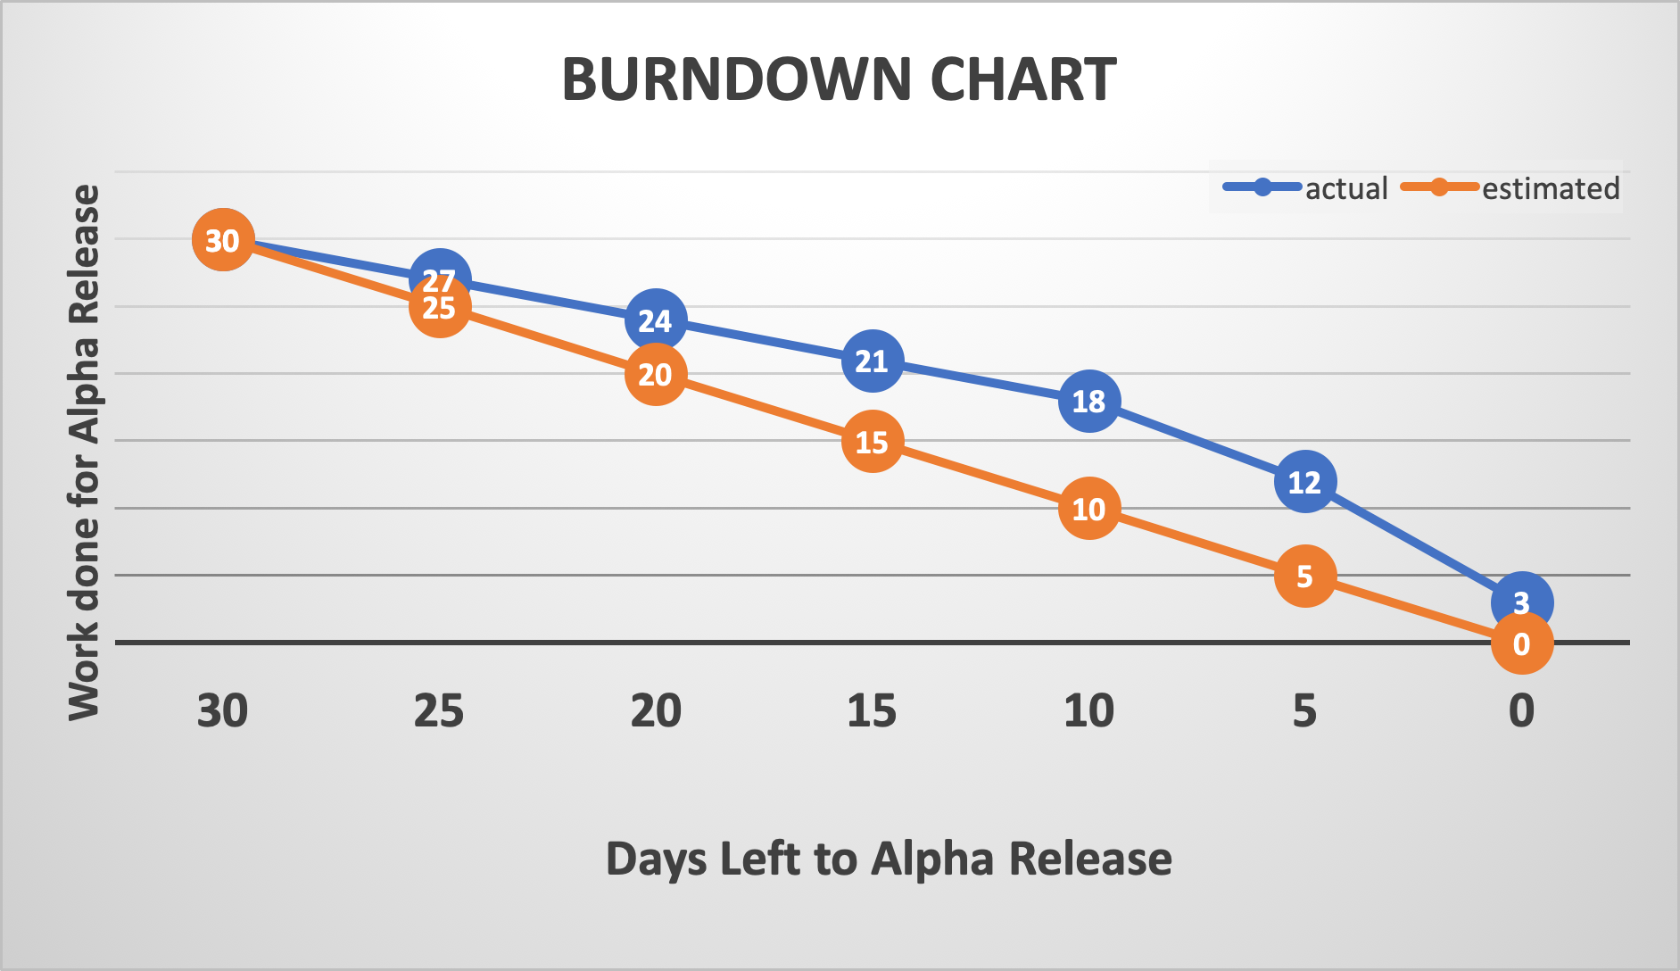**

Figure 13

**Velocity Chart**

The Velocity Chart is a means by which the teams’ velocity or pace during the Alpha Release was measured.

Alpha Release took six weeks for completion and in represented on the X-Axis. The achievement of work is shown on the Y-Axis.

The pace of the team is found to be constant during the first four weeks, as it was planned that the team members would work an average of 2.5 days in a week and about 5 hours a day.

But during the last two weeks the pace increases in order to meet the client testing deadline.

In Alpha, there were 6 User Stories to be Completed over a total time span of 30 days. But, only 3 user stories, that were to be completed in 18 days could be delivered.

The Formula for calculating the velocity of the team is:

Equation 1

Therefore the velocity of this team is (18/30)\*100 = **60%**

Figure 14

**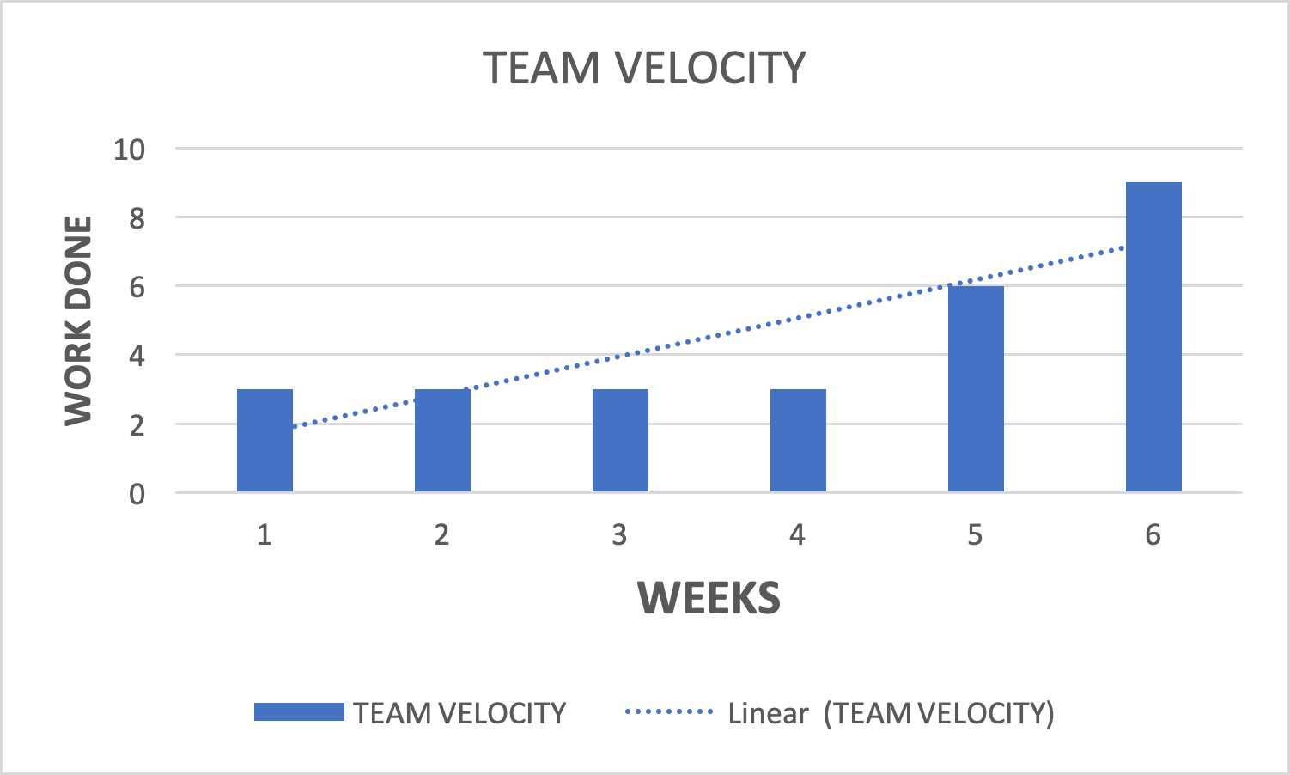Analysis:**

As depicted by both the burn-down chart and the velocity chart, it can be noted that the teams progress was not as estimated.

Hence, these charts can be used to produce better performance for the next two phases.

It is planned to achieve a least of 70% velocity rate for the Beta and Final Release.

# TECHNICAL INFRASTRUCTURE

Server and Domain

|  |  |
| --- | --- |
| **Subdomain:** | [romashka.ictatjcub.com](http://romashka.ictatjcub.com/) |
| **FTP host:** | [ftp.ictatjcub.com](http://ftp.ictatjcub.com/) |
| **FTP username:** | [romashka@ictatjcub.com](mailto:romashka@ictatjcub.com) |
| **FTP password:** | 123zxcA! |
| **Remote phpMyAdmin:** | [romashka.ictatjcub.com/phpmyadmin](http://romashka.ictatjcub.com/phpmyadmin) |
| **Database name:** | ictatjcu\_romashka |
| **Database host:** | localhost |
| **Database user:** | ictatjcu\_romashk |
| **Database password:** | 123zxc |

Table 7

## Configuration management

Git (version control) and GitHub (Web interface/storage for git projects) are superb tools that were being used. In particular, they prove to be invaluable for a group work assignment. So, for a new member to access the files for collaboration, the following steps should be taken:

Step 1: Install GIT Github Desktop

* Firstly, install Git
  + [https://git-scm.com](https://git-scm.com/)
* Secondly, install GitHub Desktop

* + [https://windows.github.com](https://windows.github.com" \t "_blank) or <https://mac.github.com>
* Create user accounts

Step 2: Follow the below link to log in to github:

<https://github.com/harshup96/Romashka>

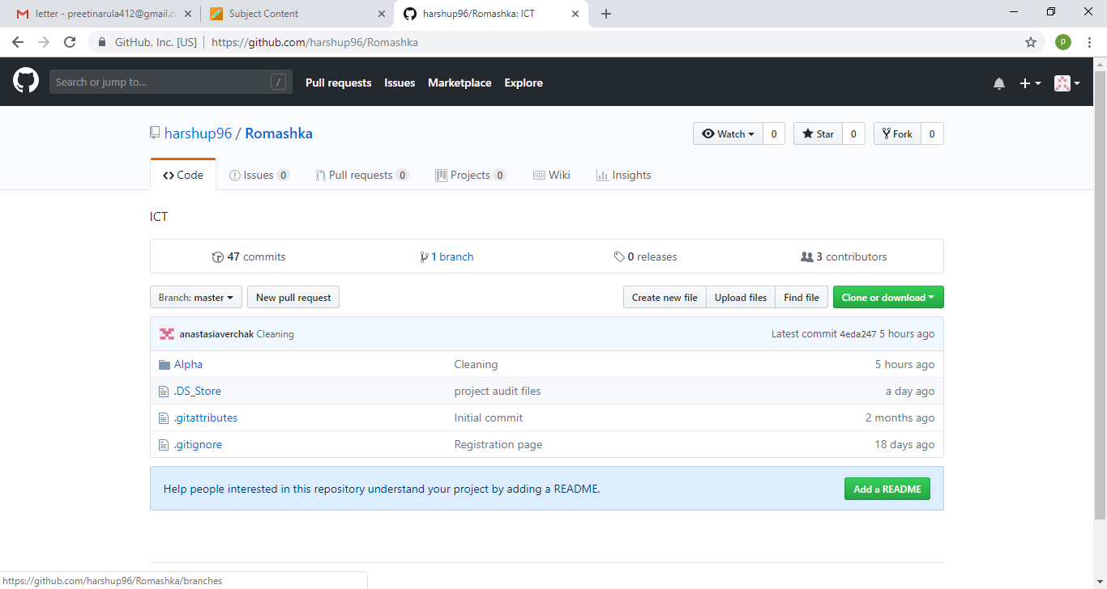

Figure 15

Step 3: To view contribution by other team members, go to contributors

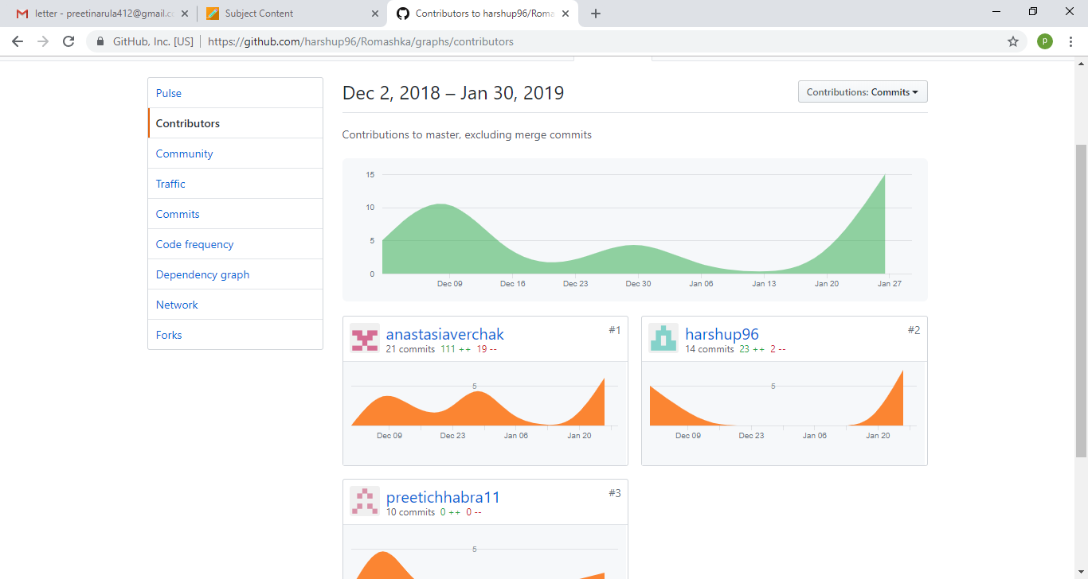

Figure 16

Step 4: To view progress in the project, click on alpha, then select any folder that is to be viewed. Example, in front end, new user can view all front end design and coding, in database folder, new user can view tables designed, etc.

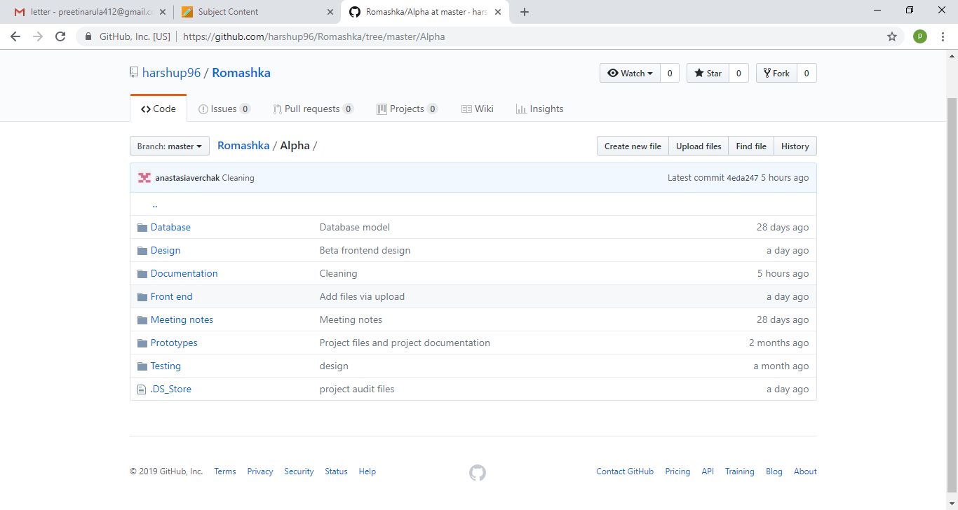

Figure 17

Step 5: Similarly, a new user can view history, upload files and commit to master. Likely, if one wants to find files, can easily search it. Suppose user wants to search for a logo of our school, then one can write Romashka/Alpha/Design/logo.png

Adobe Dreamweaver

|  |
| --- |
| It is a comprehensive tool developed by Adobe for web designers. We used Dreamweaver for designing our HTML and CSS pages. The integration with Git makes it flawless. It also supports JavaScript, PhP, etc.  Dreamweaver can also be used to Set up FTP, SFTP, WebDav, or RDS connections to upload or download files from the publishing web server.  When a remote folder is set up, a connection method must be selected for Dreamweaver to upload and download files to and from the web server. The typical connection method for this project is FTP.  Steps to set up server:  Select Site > Manage Sites.  • Click New to set up a new site, or select an existing Dreamweaver site and click the edit icon.  • In the Site Setup dialog box, select the Servers category and Click the Add New Server button to add a new server.  Setting up FTP connections  Figure 18  Once this is done, files can be put onto the remote server after a connection is established. When the files are edited, they can be uploaded again. And coding can begin. |
| Figure 19 |

HTML

|  |
| --- |
| HTML stands for Hypertext Markup Language. It supports tags for various elements of a web page. |
| Figure 20 |

CSS

|  |
| --- |
| It is basically a styling language and works in tandem with HTML to create beautiful pages.  Figure 21 |
|  |
| Figure 22  \*\* If a new team member adds up in later phases, they have to install Dreamweaver, Access on their laptops. The previously developed versions can be found on GitHub. The new team member should understand current progress and be able to learn programming needed. He/she should be able to understand the user stories and priorities. |
|  |

**The Database**

The remote database for this project is located at ‘romashka.ictatjcub.com/phpmyadmin’.

phpMyAdmin is an open source toll that provides a Graphical User Interface to work with the MySQL database management system in case of this project. With phpMyAdmin, the admin can create, alter or drop databases and tables, create or remove users and user accounts, manage the privileges granted to a particular user, import and export data in SQL and other formats, etc.

For this project, a Database named ‘ictatjcu\_romashka’ was created. The Username is ‘ictatjcu\_romashk’ and Password is ‘123zxc’. Knowledge of these credentials are sufficient for existing members of the team and any plausible new members who may join the team.

Steps for set-up of Database:

**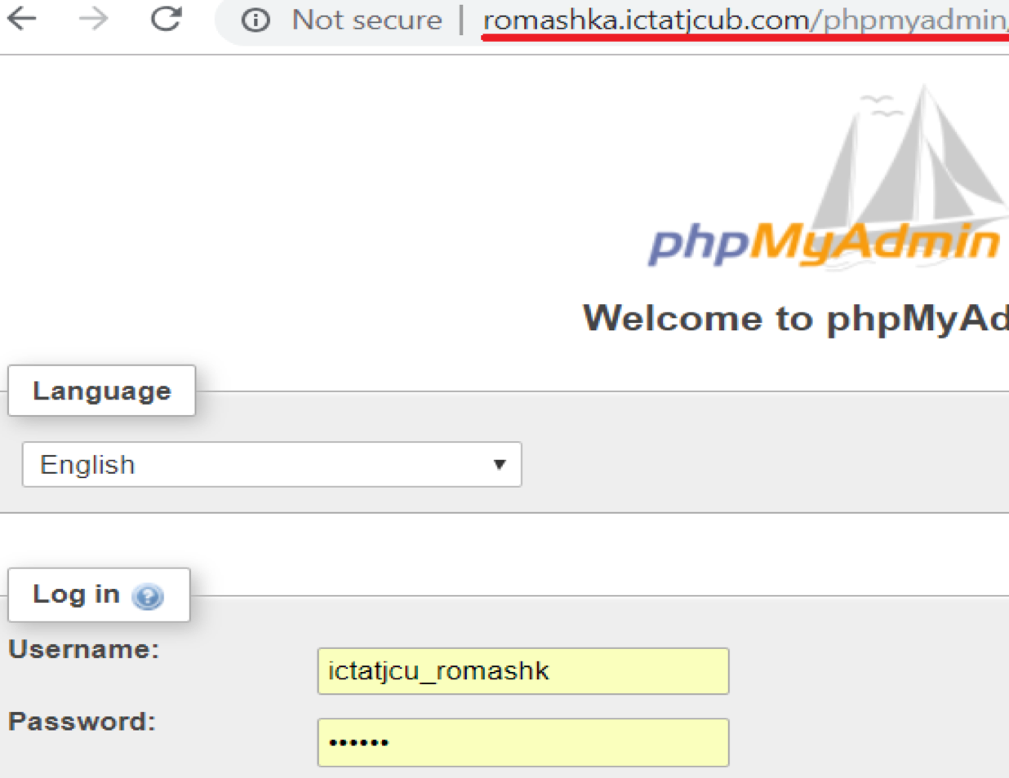Step 1: Login**

Figure 23

**Step 2: Create Tables and Insert Data (Since Database is already created)**

Tables can be created using SQL or by clicking on the ‘+New’ button on the left hand side.

Similarly, data can be inserted using the Insert tab or by writing an SQL, or my Importing or Exporting from other existing databases, or Excel files.

The Table Columns and data can be seen or edited by selecting the respective table on the side bar. Also, the Primary keys, foreign keys, indexes and relationships can be updated under the ‘Designer’ tab.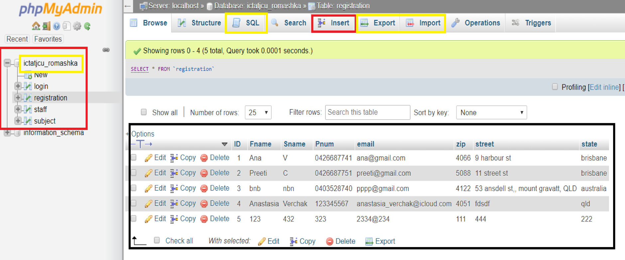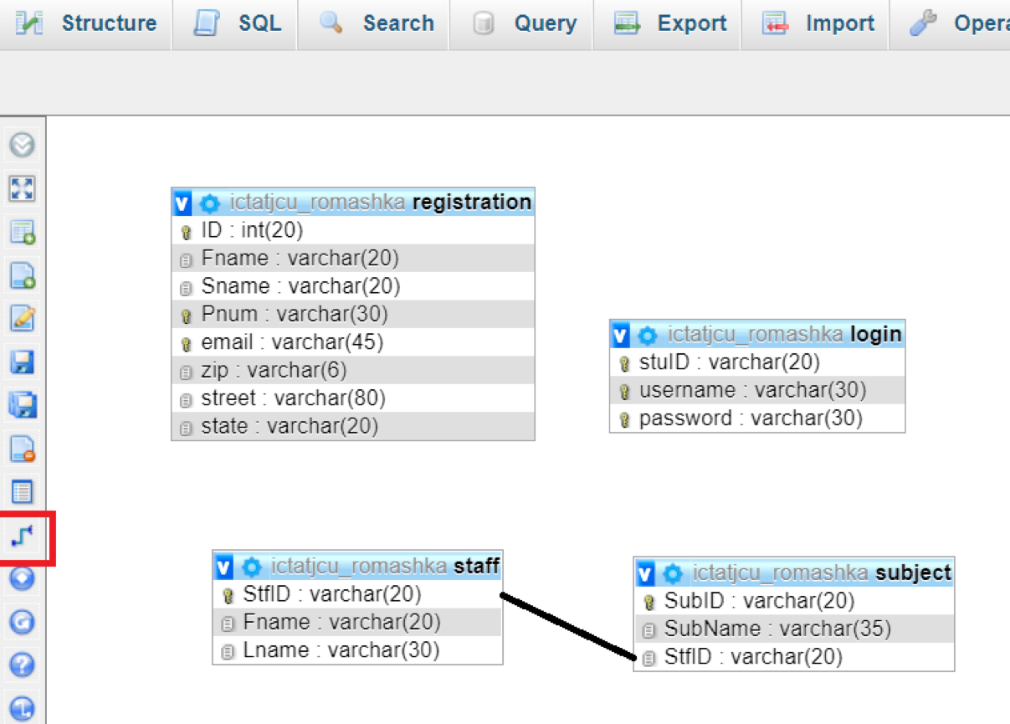

Figure 24

Figure 25

**Step 3: Creating a connection with the database.**

A config.php file contains the php code to enables connection with the database, is included in the <?php> .. ?> section of all the .php files created in the front end of the project.

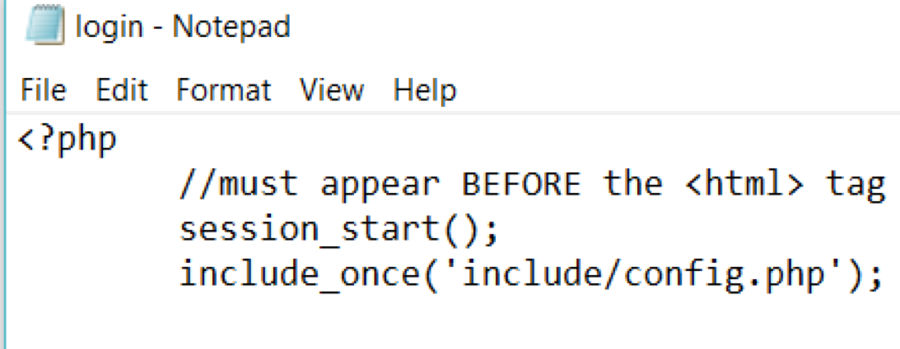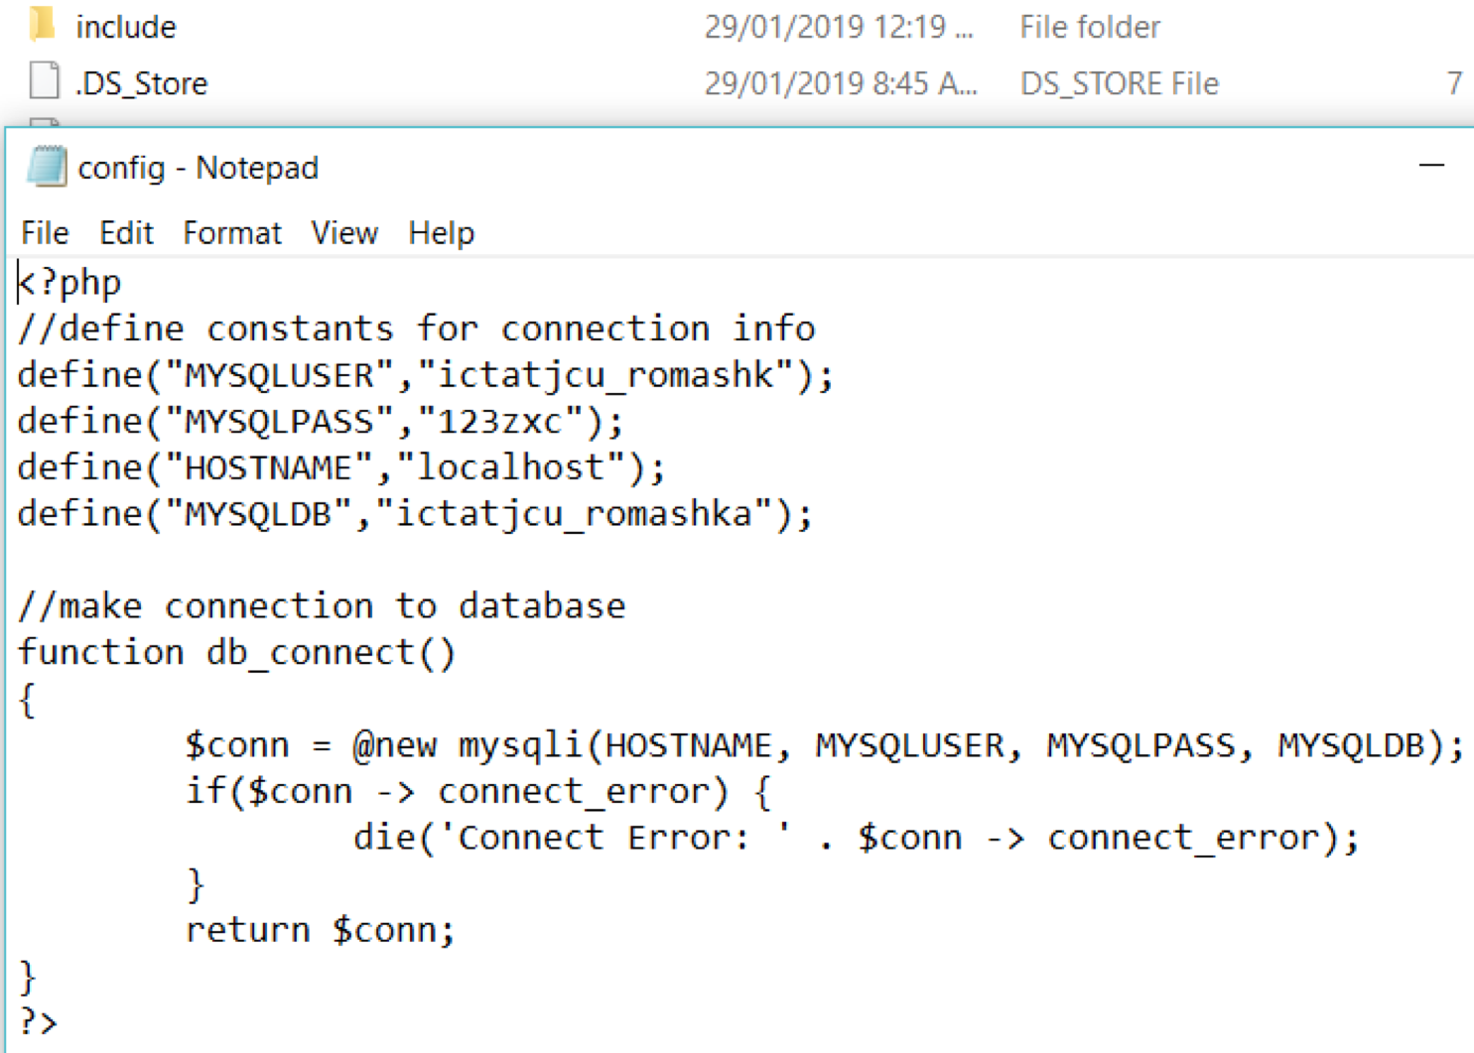

Figure 26

Once the connection is established, suitable php code is inserted in the dynamic pages of the site to for validation and other functionality.

An Example of the Registration.php code is as follows: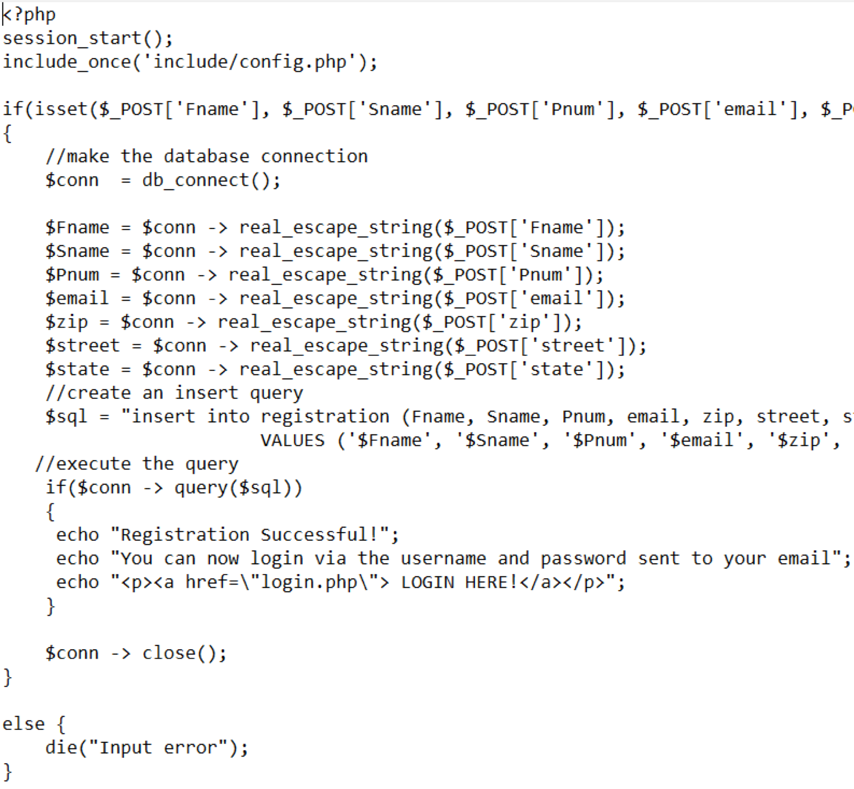

Figure 27

**THE RELEASE ENVIRONMENT**

The Release Environment chosen for this project is ‘WinSCP’. It is an open source FTP client, SFTP client, SCP client, etc. for Windows OS. Its main functionality is File Transfer between a local and a remote computer.

It provides a GUI and is integrated with Windows to provide basic operations with files and drag & drop facilities. For this project, its support with FTP protocols is utilised. It is faster compared to other hosting environments.

How to set-up the environment:

**Step 1:**

On launching WinSCP after installation, it prompts us to login.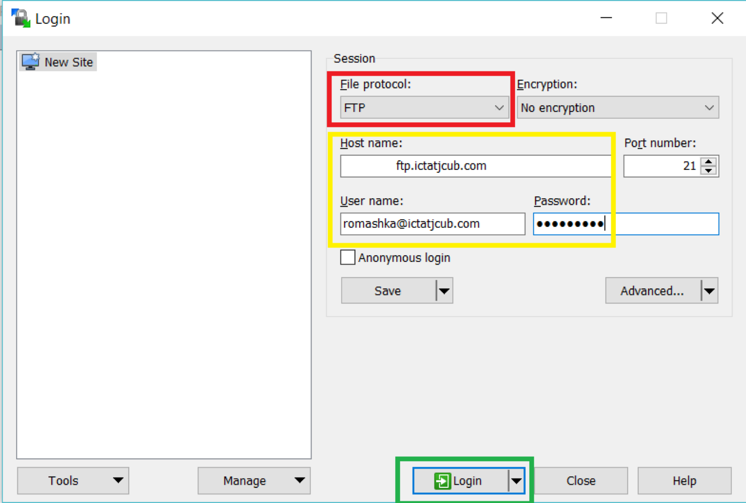

Figure 28

We use the hostname, host username and host password as the credentials to login, but before that, the File Protocol must be set to FTP.

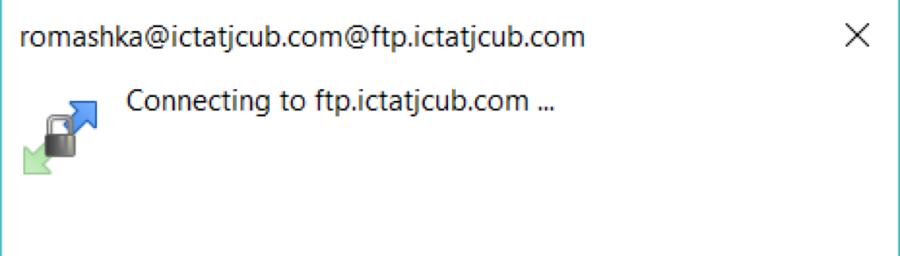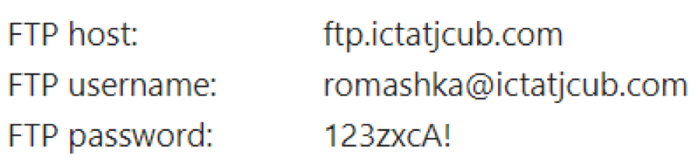For this project, the host credentials are as under:

Figure 29

When this dialogue box pops-up, it means the connection is getting established, and if successful 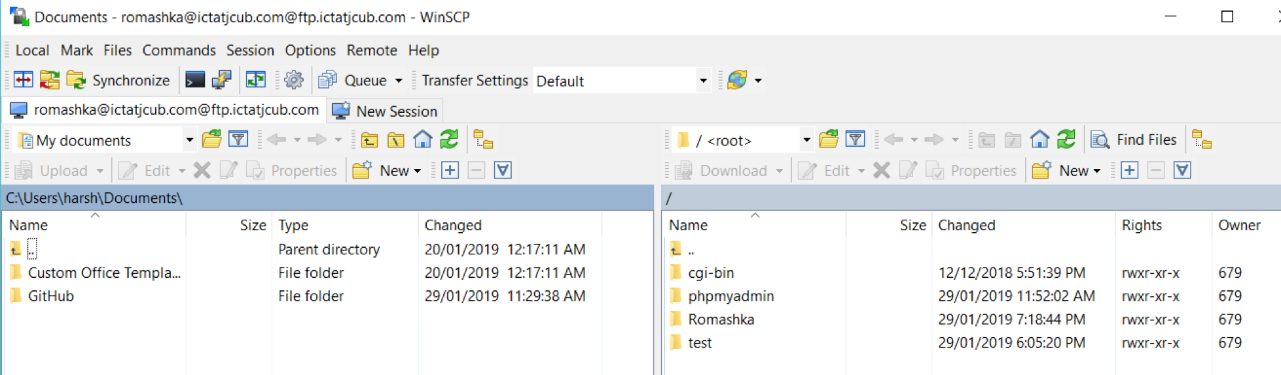the session is started.

Figure 30

On the left-hand side are the files of the local computer and on the right-hand side are the files on the remote computer.

**Step 2: Perform File Transfer**

The files of the website are all place in a folder name ‘Romashka’. We can simply drag these files from the left hand side of the screen (local PC) and drop them into the right-hand side, the remote 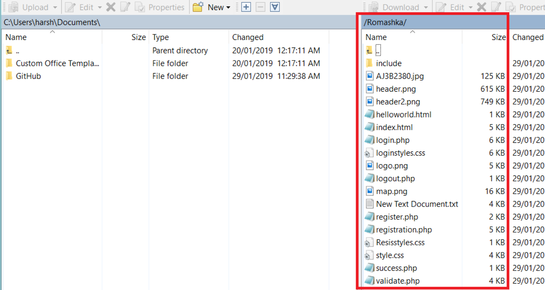computer.

Figure 31

**Step 3: Ready for the Client to test**

The files or the website is now on the remote server and can be tested by the client.

The URL for the client to go to the website is: <http://romashka.ictatjcub.com/Romashka/index.html> or simply <http://romashka.ictatjcub.com/Romashka>, because the hosting environment is configured to look for index files from the folder and run them automatically.

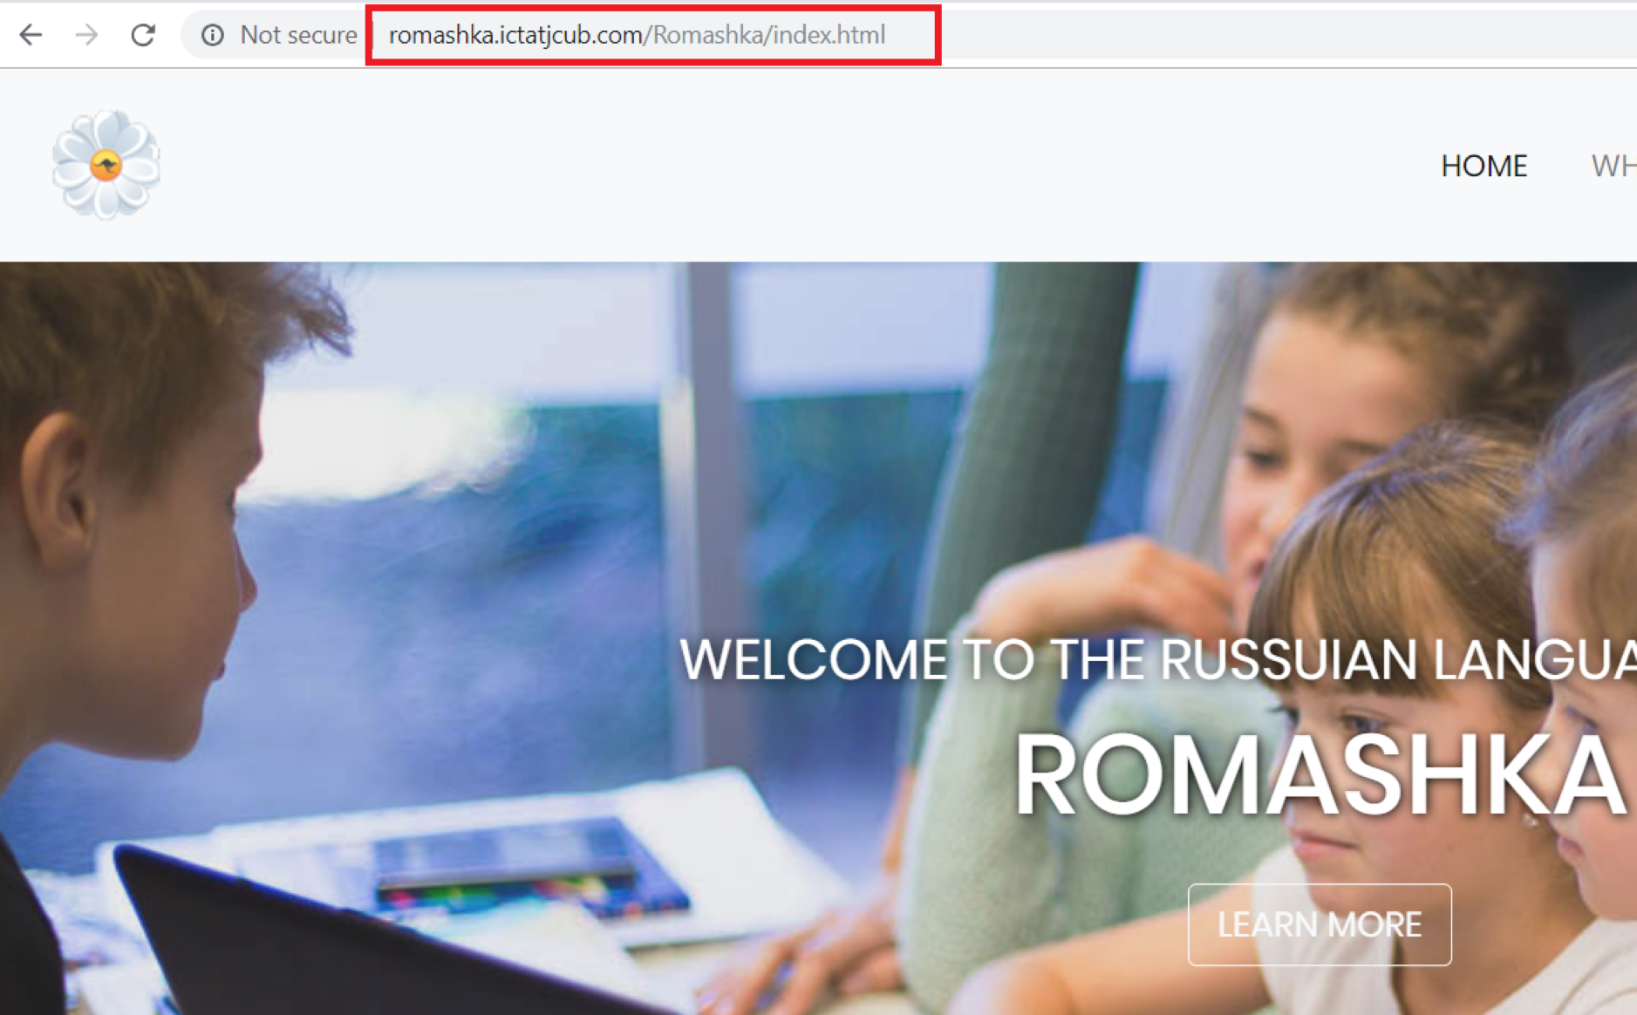

Figure 32

Any changes to the files can me made locally and re-uploaded to the remote hosting environment with no hustle.

Sometimes, due to inactivity or shutting down of the local PC, WinSCP logs out automatically for security purposes and in such cases, a login is necessary and the work can be picked up from where it was last left.

Project management tools

Project management - it is the process of achieving a particular goal within a given framework (time, budget, etc.). At the same time, the concept of PM also includes a set of tools, techniques, skills and techniques that are used to achieve the goal and can vary depending on the changing conditions in which the work is carried out (the appearance of both risks and opportunities).

Trello

Trello is a web-based collaboration service that can help organise and manage projects using cards.  
The main advantage of Trello can be called viewing several simultaneously running projects and their status at the moment. To work with a group of developers or other artists working on projects with deadlines or goals, this system can give an idea of the progress of projects.

In Trello, the emphasis is on packs of cards. Each pack shows the status of any project. For example, if select a team to work, then in the first column there will be cards with a things which has to be done, in the second - tasks in progress, in the third there may be ready tasks, in the fourth - meetings and other general things.  
Cards have many features. They are intended for discussions, polls, download files and data. It is possible to set deadlines, assign text and color labels. To assign an executer to any task, it is necessary to select it in the card from the list of work team or simply drag the executer’s avatar to the task on the right.  
It is important to note that all team members see changes in real time and can monitor the status of individual executers — online or offline.  
Trello is available both in the web interface and as an application for the iPhone. On the iPad, the service works similarly to a desktop implementation.

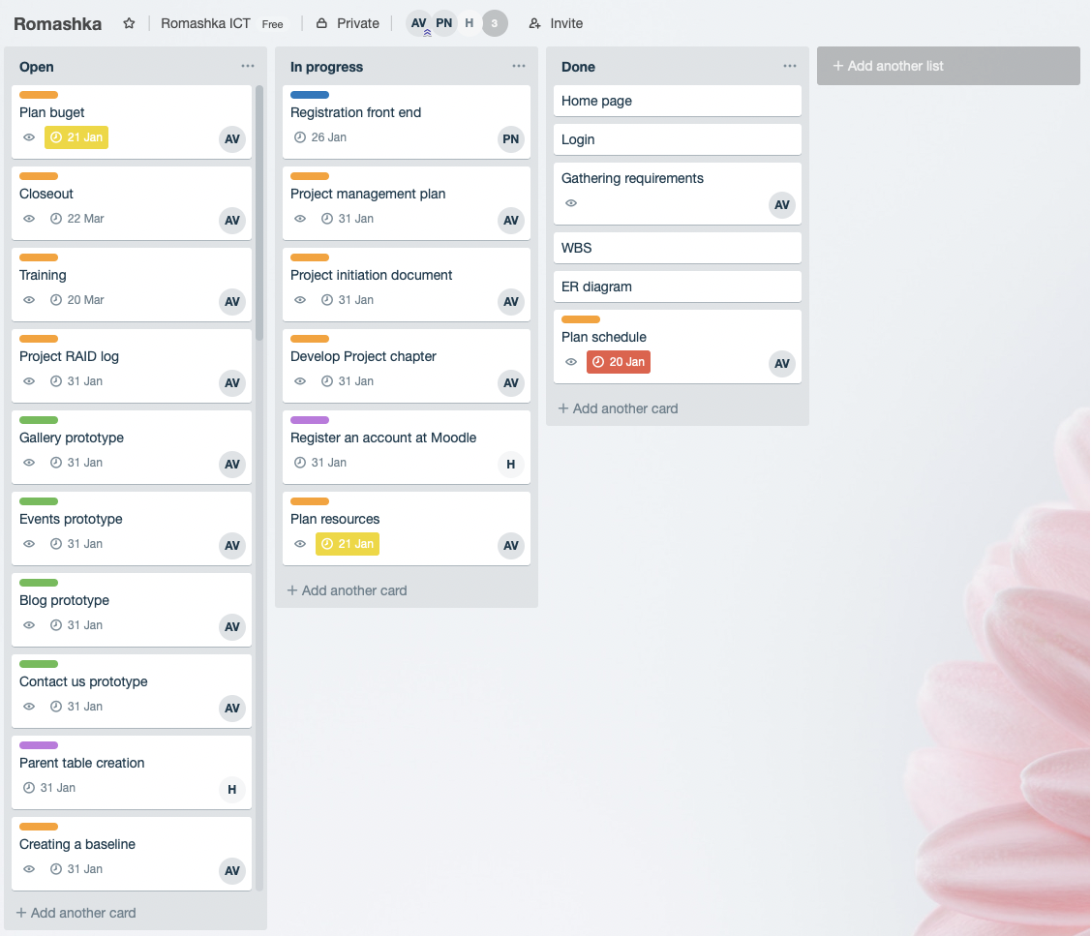

Figure 33

Slack

Slack is an online service for correspondence within the team and a large company, but in fact it is a replacement for Skype for such conversations. This service has the ability to closely integrate active dialogs with other applications. This principle allows you to monitor the progress of work on various projects using one interface and remove unnecessary information.

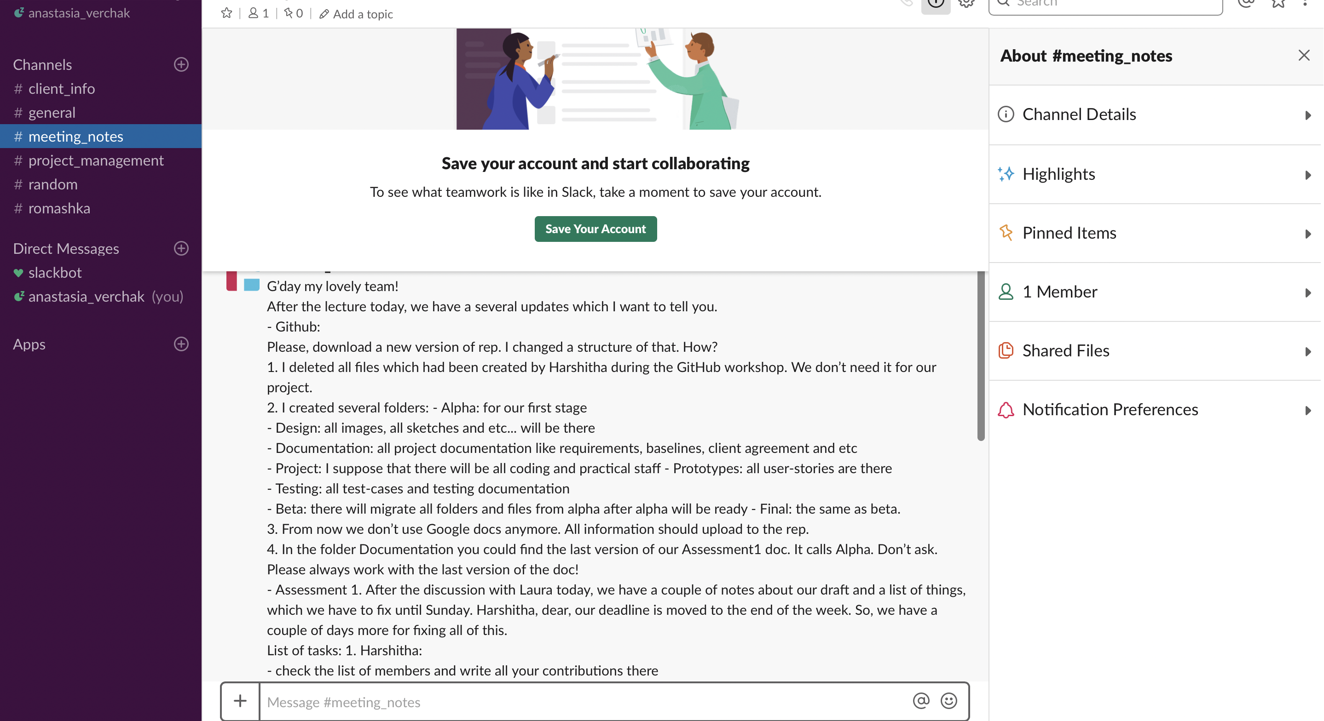

Figure 34

GanttPro

GanttPro - Gantt chart that allows project manager to plan and manage projects online, visualise processes, create tasks and assign them to participants, set deadlines and percentage of individual tasks and the project as a whole, add milestones and share the created Gantt schedule with the team and with clients with the right to view or edit.

# FUTURE PLAN – BETA AND FINAL RELEASE

## Migrating to Moodle:

Due to complications and meeting deadlines, the User Story- Dashboard in Alpha release has now been moved to Beta Release and will be hosted by Moodle.

What is Moodle?

Moodle is a Learning Management System, designed for instructors, administrators and students to create their own personalised learning environments.

The advantage of Moodle is that it is an open source software available under the GNU Public License and can be simply installed onto the web server. It is developed in Linux using Apache, MySQL and PHP.

The hardware requirements for Moodle are:

Disk Space- 200MB for the code and minimum of 5GB to store content.

Processor- 2GHz dual core is recommended.

Memory- 1GB or more is recommended.

After thorough research, it was decided that Moodle is the best suited LMS for this project because of a number of benefits it has.

In Moodle, a Dashboard is available for students to check daily notifications when course contents are added, the information about enrolled subjects and the instructors of the respective courses.

This feature is the most desired feature for the project ‘Romashka’- as it distinguishes it from other Language school websites.

The following figure shows Moodle’s Student View:

An interesting feature provided by Moodle is that students can search within their courses the discussions had with peers or teachers. Any virtual classroom sessions conducted are recorded and the chat histories are available for students to review them whenever the need be.

Moodle allows random and automatic allocation of students into groups. The groups can be edited only by the teachers.

Moodle provides an extra feature called the Moodle Community Hub where students or instructors can access a location to share ideas or resources with peers, they can join in with communities hosted by other websites and yet is secure and can be set to be controlled only by the admin.

# The assignments are submitted in a similar fashion but in Moodle, the assignments are saved as drafts if the student missed to click the submit button and closes the window.

# BETA RELEASE PROPOSAL

According to the results of Alpha release, new Beta plan had been created and accepted by both sides.

|  |  |  |  |
| --- | --- | --- | --- |
| Title | Description | Client Priority | Time estimate (days) |
| Bug fixing | See AlphaTestReport.pdf | 10 | 5 |
| Confirmation page | presents the total fee to be paid | 20 | 5 |
| Payment page | process the payment | 20 | 5 |
| Subject Selection page | Students can enroll by choosing the subjects for the first time and confirm their enrollment | 20 | 5 |
| Edit Selection page | Edit the choices of subjects (withdrawing, changing of subjects) | 20 | 5 |
| Dashboard | Student has an access to his study activities | 10 | 5 |
| Contact us page | Access to the contact details of the school to find its location, phone number for any queries. | 20 | 2 |
| Why we page | Access to the information about the school involving teaching programs, events ,etc. | 20 | 5 |

Table 8

* Gantt chart could be found in the attached file GanttChart.pdf
* WBS diagram could be found in the attached file Romashka\_WBS.jpg

# BETA RELEASE PROTOTYPES

|  |
| --- |
| **User story: Payment page**    Figure 35 |
|  |
| Figure 36 |
|  |
|  |
| **User story: Why we**  Figure 37 |
|  |
|  |
| Figure 38 |
|  |
| **User story: Contact us** |
|  |
| Figure 39 |
| **User story: Dashboard** |
|  |
|  |
| **User story: Enrolment** |
| Figure 40 |

User stories:

* Dashboard,
* Enrolment,
* Confirmation and
* Subject selection

Are planned to be created using Moodle external service. That is, the design prototypes would be provided by Moodle as well.

# REPORT CONCLUSION

In conclusion, Alpha stage has been successfully completed by the team within the deadline and most of the user stories were delivered with good results after the client testing.

There have been some changes to Alpha, for example the User Story- Dashboard will now be supported by the LMS – Moodle.

Work on Beta is set to start soon as the team has now thoroughly learnt all the tools and technologies required for developing and hosting this project and are ready to carry on with the next proposed phases of this project.

***List Of Figures***

Figure 1 5

Figure 2 5

Figure 3 6

Figure 4 6

Figure 5 7

Figure 6 8

Figure 7 8

Figure 8 9

Figure 9 10

Figure 10 10

Figure 11 11

Figure 12 11

Figure 13 15

Figure 14 16

Figure 15 18

Figure 16 18

Figure 17 19

Figure 18 20

Figure 19 20

Figure 20 21

Figure 21 21

Figure 22 22

Figure 23 23

Figure 24 24

Figure 25 24

Figure 26 25

Figure 27 26

Figure 28 27

Figure 29 28

Figure 30 28

Figure 31 29

Figure 32 30

Figure 33 31

Figure 34 32

Figure 35 35

Figure 36 36

Figure 37 36

Figure 38 37

Figure 39 38

Figure 40 39